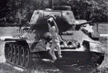
Scenes of World War II
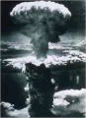
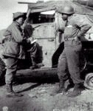
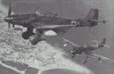

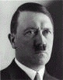
Adolf Hitler

